1. Create the following users, groups, and group memberships:
-A group named admin
-A user harry who belongs to admin as a secondary group
-A user natasha who also belongs to admin as a secondary group
-A user sarah who does not have access to an interactive shell on the system, and who is
not a member of admin
-harry, natasha, and sarah should all have the password of "redhat@123?"

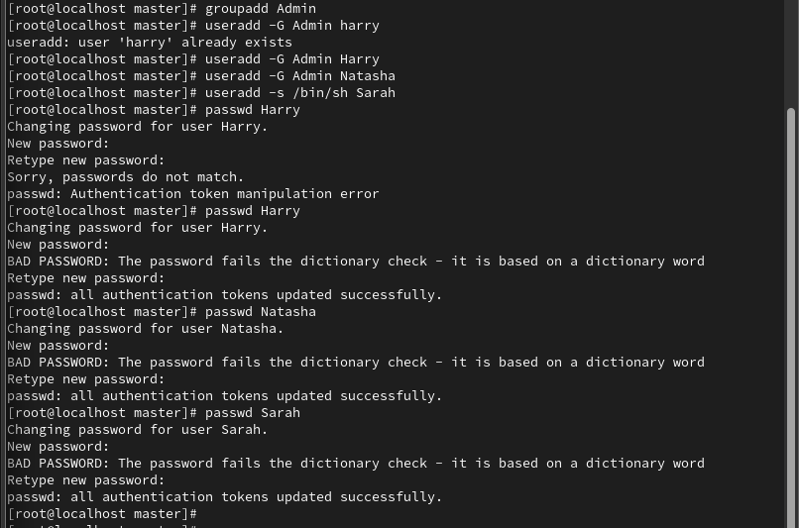

2. Create a collaborative directory /common/adm with the following characteristics:
-Group ownership of /common/adm is admin
-The directory should be readable, writable, and accessible to members of admin, but
not to any other user. (It is understood that root has access to all files and directories on
the system.)
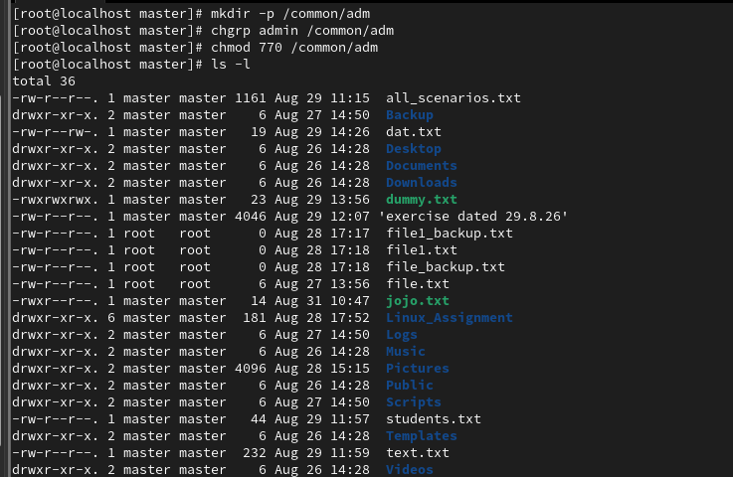

3. Copy the file /etc/fstab to /var/tmp. Configure the permissions of /var/tmp/fstab so
that:
-The file /var/tmp/fstab is owned by the root user.
-The file /var/tmp/fstab belongs to the group root.
-The file /var/tmp/fstab should not be executable by anyone.
-The user harry is able to read and write /var/tmp/fstab.
-The user natasha can neither write nor read /var/tmp/fstab.
-all other users (current or future) have the ability to read /var/tmp/fstab

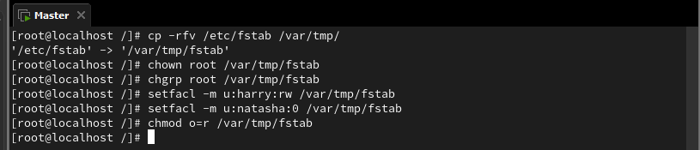

4. You need to change the owner of a file named /tmp/exe from harry, who is a member of
the users group, to natasha, who is a member of the editors group. Assuming you want to
change both user and group owners, which command will do this?
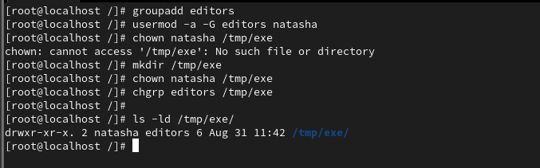
5. Create two groups as developers and testers. Add users Rahul to developers group and
Nisha to testers. Then, create a shared directory as /project/shared where members of
both groups can read and write files but others have no access. Ensure all new files are
created inside and inherit the group ownership.
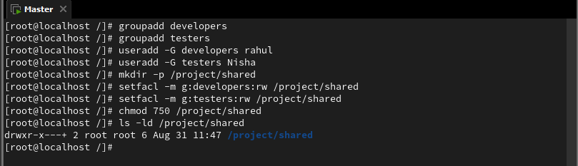

6. You need to change the permissions of a file named schedule.txt such that the file
owner can edit the file, users who are members of the group that owns the file can edit it,
and users who are not owners and don't belong to the owning group can view it but not
modify it. Which command will do this?
